Auto Window Roll Up (by Matrix)

Ok here we go 1st you need to purchase a Electric Window/Sunroof Interface from Microscan, here’s a link to the product you require is AN0031 (http://fordprobestore.co.uk/store/product_info.php?products_id=433)

Next you need to make sure you have an alarm fitted that already operates the C/L on your car otherwise this won’t work.

Here’s a brief description of how it works…the window interface is wired into the existing wiring going to the window control panel on the drivers door, it can be fitted completely into the drivers door without running any wires back to the alarm!

The instructions that come with the interface tell you that you have to run a wire back to a negative pulse on your alarm… wrong you don’t have to at all, when you press the remote key fob on your alarm the doors lock or should do if they don’t leave now this mod is not for you, if they do then were ok.

The signal wire that told your doors to lock when you pressed the fey fob is a Negative pulse and will do the job perfectly, ok enough explanations lets get down to business.

1 Remove R/H door card (simple)
2 Remove speakers (even easier)
3 Locate window interface (see Pic1)

pic1 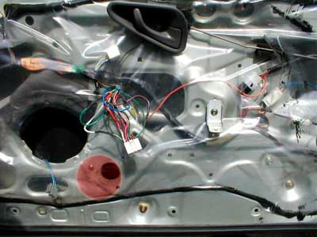

I found this was the best place to mount the interface with the plug at the top and a spire clip on one of the mounting lugs to secure it.
4 Locate the multi plug that connects into the R/H door window control panel (bigger of the two)
pic2 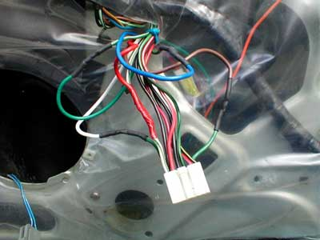

Now the tricky bit, connecting up the wires…NO! It’s quite straightforward really. I like to solder my connections and then shrink-wrap then it makes the install look much neater.

White/Green trace (from the multi plug) = Red (12v Fused from interface)
Green/Blue trace (from the multi plug) cut the wire in half from the plug = Brown (from interface)
Green/Blue trace (from the multi plug) = Blue (connects to the other end of the wire you just cut)
Green/White trace (from the multi plug) cut the wire in half from the plug = White (from interface)
Green/White trace (from the multi plug) = Green (connects to the other end of the wire you just cut)
Black (from interface) to a good earth
Pink (from interface) not used

Ok only one more wire to connect and this one goes to the 4-pin multi plug that operates the C/L (central locking) see pic3

pic3 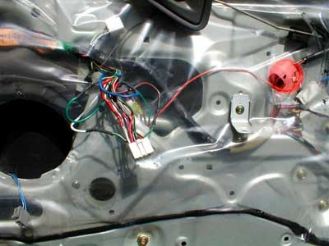

Orange (from interface) = Green (C/L 4-pin multi)
pic4 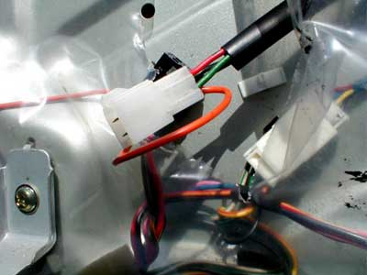

If you get the Orange wire wrong you may find the windows go down when you press the alarm key fob to lock the doors!
That’s it all done reconnect the window control panel to both the multi plugs put the line fuse in on the Red wire from the interface and test. Once testing is complete and you are happy re-assemble the door card and away you go.
I hope this is of some help to somebody and I think it’s a pretty cool mod myself, nothing better than time & labour saving gadgets.

