Flaking Lacquer

Equipment required

Bucket; this needs to be filled with clean water with a little washing up liquid. It’s best to change the water between preparation stages.

Rubbing down block; best to use a hard rubber block (don’t use wood)

Wet n Dry paper; varying grades, 1000, 1200, 1500, 2000.

Scotchbrite; Grey (never use red scotchbrite on metallic paint surfaces)

Masking paper and tape

Spirit/Panel wipe; this is a fast evaporating solvent used for cleaning the area between preparation stages

G3 polish

Lacquer; if you have access to a spray gun and compressor use it as it gives much better finish, that said it is possible to get good results from spray cans

Spot Repair

The following guide gives directions for spot repair of flaking lacquer. If there are multiple spots on one panel it is best to flat and re lacquer the whole panel. The technique for doing a whole panel is basically the same just on a larger scale.

Surface preparation
As with any painting the panel preparation is the key to a good finish
Firstly give the area a good wash to ensure there aren’t any bits of dirt or grit that are going to causes more scratches.
Start with the 1000WnD on the block use plenty of water and lightly flat over the area of damaged lacquer, try to keep the Flatting as localized as possible to prevent the amount you need to paint from growing. Try to keep the area you are working on as clean as possible, free from any flatting residue; this will help you see exactly what you are doing.
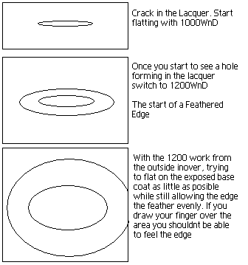

Once you have the paint edge feathered so you can’t feel any hard edges and the lacquer is nice and evenly flatted, go over the area with the 1500WnD to remove any scratches from the previous stages.
Give the area a good wash, dry it and go over with the panel wipe to remove any flatting residue. If you haven’t used panel wipe before you pour a small amount on a clean cloth and wipe it over the area then with a clean dry cloth rub over the treated area to remove the solvent and any contaminants with it.
Once you have cleaned the area and there is nothing but 1500WnD scratches remaining, take the grey scotchbrite keep it nice and wet and lightly go over the whole area including 6 to 8 inches surrounding the flatted area (if the affected area is close to the end of the panel take it right to the edge), when using the scotchbrite try to keep your fingers close together and use your hand sideways to avoid leaving finger pressure scratches.
When this is done dry the area, you should have nice dull paint, if there are any places that are more shiny than the rest give it a little more with the scotchbrite and dry again to check.
Give the area another good panel wipe and you are ready for masking.

Masking

You need to cover all the areas you don’t want to get the lacquer on so it’s best to mask as much as possible.
If you place the tape and masking paper closely around the scotchbrited area so that all the scratched area can be seen but none of the shiny paint
In order to try to eliminate a hard edge its best to try back masking where ever possible.
Back masking is rolling a length of 2” masking tape sticky side out (try not to fold the tape) and then sticking it to the panel and then sticking the masking paper to the tape.
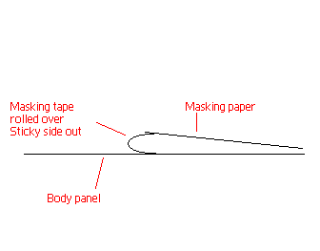
In cases where the area you have prepared has gone up to a panel edge, place half the masking paper down the panel gap and stick the other half to the adjacent panel and then masking paper to the tape on the adjacent panel.
Once all the masking has been done give the area a final panel wipe to clean it of any possible contaminants before you start applying the lacquer.

Quick note about “flash time”

Flash time is the time between coats. When painting it is necessary to allow the paint to dry to a tacky state but not to a hard finish. You will find the flash time stated on the side of the spray can you are using it is usually 10 to 20 min but this varies considerably depending on the temp and spraying conditions. Personally during each coat I will make a point of spraying a patch on the masking paper, this gives a place you can stick your finger to check how dry the paint is. It should be tacky to the touch but not sticky and wet.

Lacquer application

Now for the fun bit
Before you start painting make sure you have shaken the can well and as per the instructions on the can. Test the can out on a scrap of masking paper to ensure the lacquer is flowing well and there aren’t any blockages in the cap.
Start by spraying a small area only covering the area that has been flatted back to build up the area, If using a spray can use light coats to build up the layers, it should be sprayed from approx 6” away (I usually use my hand span to judge this).
Between each coat while you are waiting for the lacquer to flash off make sure the cans spray cap is clean so the next coat goes on easily and evenly.
When you have a few light coats covering the flatted area start to make your coats larger, gradually expanding until the whole area is covered.
For the last coat of lacquer I usually make it a nice wet coat, this will help improve the finish of the paint and can eliminate the stippled effect you can get because of using light coats.
The paint can take up to 12-24 hours to cure fully depending on the lacquer and the conditions. Check the side of the can for manufacturers curing times.

Flatting and polishing

Once the paint is fully cured its time to polish.
Take the 2000WnD on your rubber block and plenty of clean water with a little washing up liquid. Start by feeling your paint finish, inevitably you will have little bits of dust in the paint finish gently flat these down until you can’t feel them anymore, then go over the rest of the area to reduce the orange peel and slight rippling of the paint finish. Don’t over do it, remembering that you are removing lacquer and you don’t want to have to start again if you go through, wherever possible don’t flat the outside 2” of the freshly lacquered area as it can adversely affect the way the lacquer blends in to the original finish.
Once you are happy that as much of the dust and orange peel has gone; move on to polishing the whole area of freshly painted lacquer. You will need to use G3 on a clean cloth with plenty of water and elbow grease. Keep cleaning and checking as you go.
Remember G3 is abrasive; you are replacing 2000WnD scratches with finer polish scratches and to do this the polish wears down the lacquer.
Once you are happy that the lacquer has blended in and has a nice shine, give the whole panel a quick going over with a light polishing compound and finish in your favourite wax.

